SNAKES AND LADDERS PHYSICAL CHALLENGE
SECONDARY

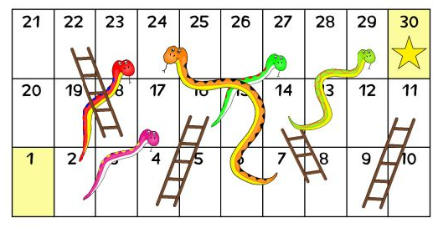

BOX JUMP
2 FOOTED JUMPS ONTO HARD SURFACE - eg BOTTOM STEP OF STAIRS ( BE CAREFUL IF USING OTHER SURFACE)
STEP UPS
USE THE STAIRS AND REMEMBER TO STEP ONTO WHOLE FOOT NOT JUST YOUR TOES
RULES:
- ONLY USE 1 DICE
- PLAY INDIVIDUALLY PERSONAL CHALLENGE OR WITH AS MANY PEOPLE AS YOU LIKE
- CAN BE DONE INSIDE OR OUTSIDE
- WARM UP BEFORE STARTING CHALLENGE
- SAFETY FIRST WHEN DOING CHALLENGES
- MODIFY CHALLENGE WHERE APPROPRIATE
NUMBER  CHALLENGE | EASY CHALLENGE | MEDIUM CHALLENGE | HARD CHALLLENGE | SUPERSTAR CHALLENGE
1 – GET STARTED
2 - PLANK | 45 secs | 90 sec | 2 mins | 3 mins
3 - PRESS UPS | 10 | 20 | 30 | 50+
4 - BURPEES | 10 | 20 | 30 | 40+
5 – STEP UPS | 30 | 45 | 60 | 75+
6 – PARTNER SELECTS CHALLENGE
7 – BICEP CURLS | 10 | 15 | 25 | 35+
8 – EXERCISE OF YOUR CHOICE
9 – LIFT IT | 15 items | 20 items | 25 items | 35+ items
10 - CRUNCHIES | 15 | 25 | 30 | 40+
11 – SIT UPS | 15 | 25 | 30 | 40+
12 – BOX JUMPS | 10 | 15 | 20 | 25+
13 – PRESS UPS | 10 | 20 | 30 | 50+
14 – PARTNER SELECTS CHALLENGE
15 – PLANK - 1 ARM | 45 secs | 90 sec | 2 mins | 3 mins
16 – YOUR CHOICE
17 – STEP UPS | 30 | 45 | 60 | 75+
18 – BICEP CURLS | 10 | 15 | 25 | 35+
19 - BURPEES | 10 | 20 | 30 | 40+
20 – LIFT IT | 15 items | 20 items | 25 items | 35+ items
21 - CRUNCHIES | 15 | 25 | 30 | 40+
22 – SIT UPS | 15 | 25 | 30 | 40+
23 – STEP UPS | 30 | 45 | 60 | 75+
24 – PARTNER SELECTS CHALLENGE
25 – PLANK OF YOUR CHOICE | 45 secs | 90 sec | 2 mins | 3 mins
26 – BOX JUMPS | 10 | 15 | 20 | 25+
27 – BICEP CURLS | 10 | 15 | 25 | 35+
28 – PRESS UPS | 10 | 20 | 30 | 50+
29 – YOUR CHOICE EXERCISE
30 – CHALLENGE COMPLETED
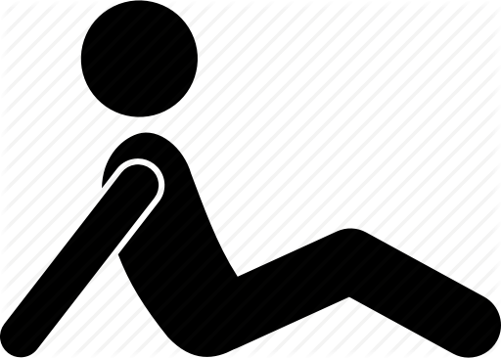
PRESS UPS
EASY MEDIUM/HARD CHALLENGE
LEG LIFT – USING FEET LIFT OBJECTS eg GLOVES, SCARVES, SOCKS FROM ONE SIDE TO THE OTHER
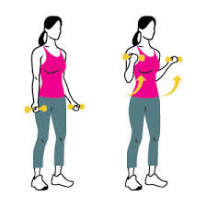
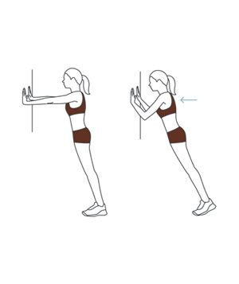
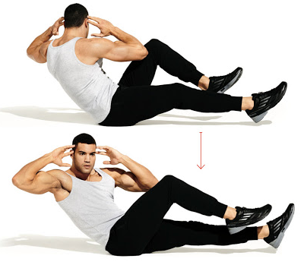
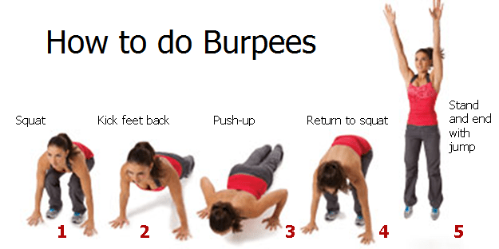
BICEP CURL – USE TIN OF FOOD IF NO HAND WEIGHTS. HANDS UP TO SHOULDER TOGETHER OR ALTERNATE
CRUNCHIES
KEEP FEET OFF THE FLOOR
SIT UPS
1. EASY 2. MEDIUM 3. HARD / SUPERSTAR

